**Defect Report**

* **Defect Id: 16**
* **Status: Closed**
* **Reported by: Bishoy**
* **Asserted to: Malek**
* **Date:**  **13/5/2023**
* **Defect description:after entering the student activity mark=-1, an** *INVALID_STUDENT_ACTIVITIES_MARK* **exception must be thrown but nothing was thrown, and the student activity mark was stored normally. Student activity mark must be an integer value ranges from 0 to 10**
* **Steps:**

1. **Open the application**
2. **Enter the student activity mark = -1**
3. **Run the program**

* **Severity: Low**
* **Priority: High**
* **Date Closed: 14/5/2023**
* **Fixed By: Malek**
* 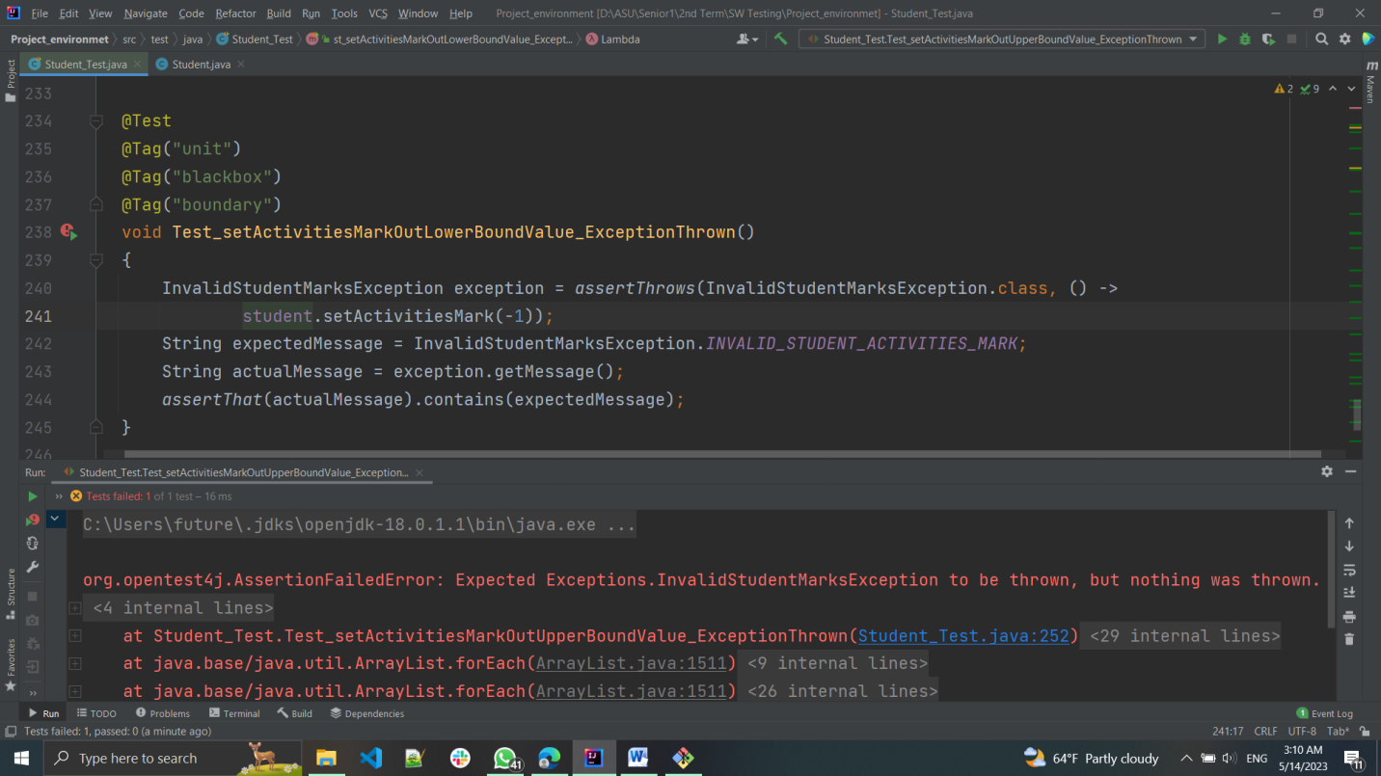**Screenshot for the Defect:**
* **Screenshot after fixing:**

